# CS 255 System Design Document Template

This template lays out all the different sections that you need to complete for Project Two. Each section has guidance to prompt your thinking. You will need to continually reference the interview transcript as you work to make sure that you are addressing your client’s needs. There is no required length for the final document. Instead the goal is to complete each section based on what your client’s needs are. Remove this note when you are finished, and replace all bracketed text with the relevant information.

## UML Diagrams

### UML Use Case Diagram

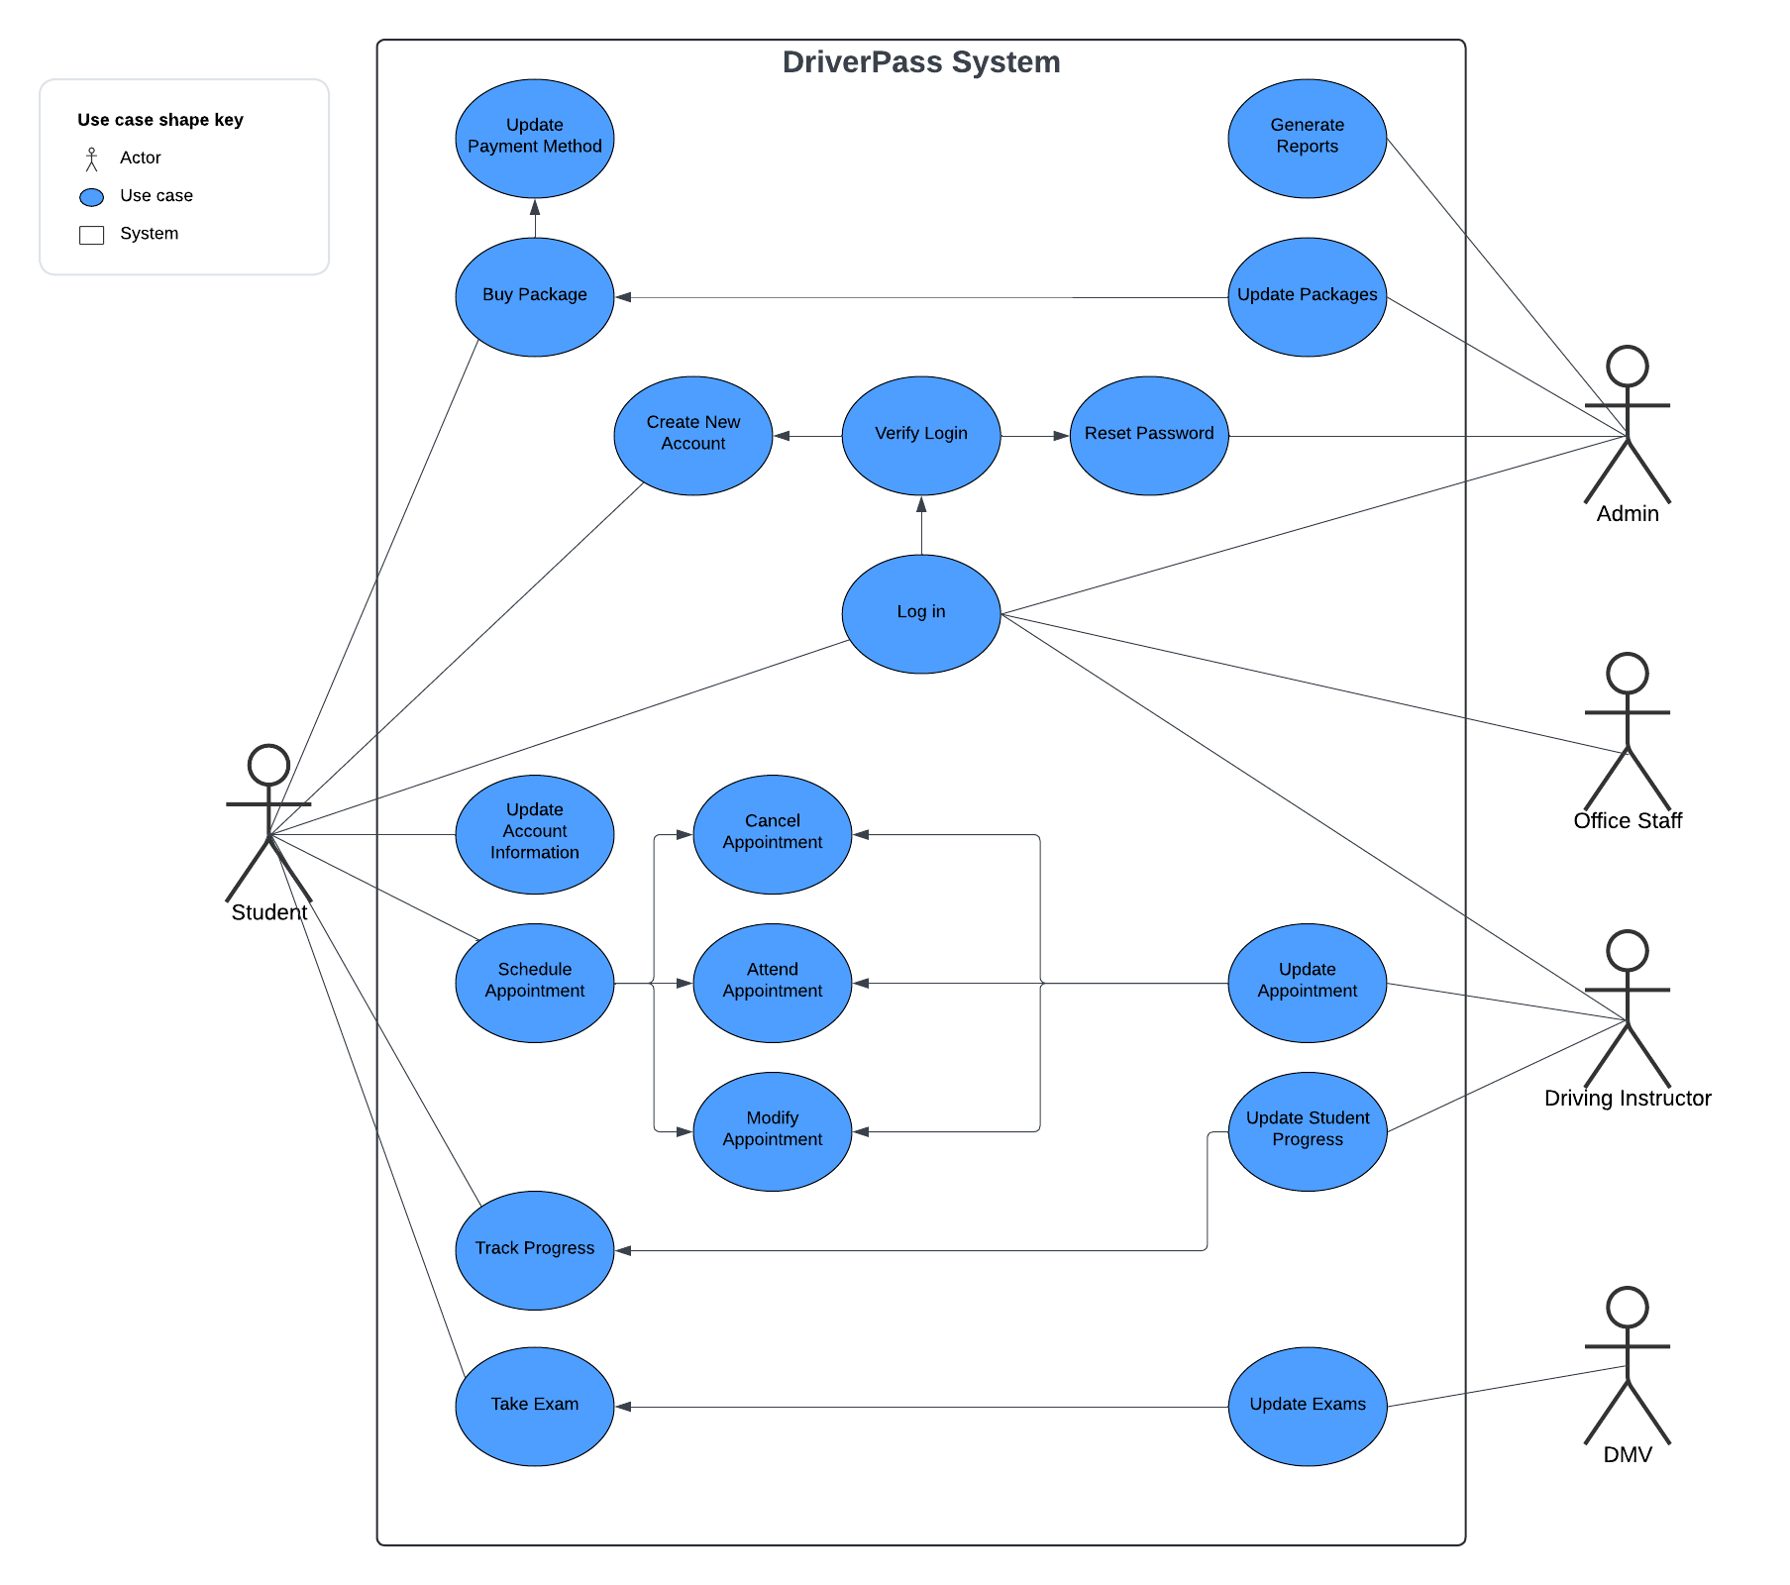

### UML Activity Diagrams

### UML Sequence Diagram

### UML Class Diagram

## Technical Requirements

Hardware requirements:

* At least one server, offsite and managed by another company.
* Computers for interacting with the system as well as all required peripherals.
* Business class internet connection.
* Phone service.
* Electrical hardware sufficient to support multiple computers at once without overloading.

Software requirements:

* Software that is currently in development.
* Windows operating system due to its compatibility and stability.
* Encryption and security software to protect customer information.
* Web browser application.
* System to accept online payments.

Tools and Infrastructure:

* Development environment for the DriverPass software.
* Payment system to process online payments from customers.
* Building to house operations.
* Garage to house vehicle fleet.